**MANAGEMENT:**

# MANAGEMENT

**Management By Koontz :** The process of designing and maintaining an environment in which individuals, working together in groups, efficiently to accomplish the organizational objectives **Management By Henri Fayol :** Management is conduct of affairs of business, moving towards its objectives through a continuous process of improvement and optimization of resources **Management By Mary Parker Follete :** Management is the art of getting things done through people.

**Management by George R Terry** : Management is a process consisting of planning, organizing, directing, and controlling, performed to determine and accomplish the objectives by use of people and resources.

**Management by ILO :** Management is the complex of continuously coordinated activity by means of which any undertaking administration/public or private service conducts its business. **Management by Lawrence A. Apple** : Management is guiding human and physical resources into a dynamic, hard hitting organization until that attains its objectives to the satisfaction of those served and with a high degree of morale and sense of attainment on the part of those rendering the service .

**Nature**

# Nature & Characteristics of Management:

* Management is multi disciplinary
* Universal application
* Dynamic nature of Principles of management
* Decision Making
* Management Principles are relative and not absolute
* It is a Discipline/Career/Profession
* Management is a Science and an Art as well

## Important Characteristics of Management

* It should be stable
* It should be applicable to all kinds of organizations
* It is transparent
* Its approaches are very clear and goal oriented
* It should be simple yet effective
* It should be responsive to economic, technological, social, political factors that affect the areas of operation
* It should have well defined goals
* It should have good planning, organizing, staffing, directing and controlling functions.

Roles of Manager

* The figurehead role (performing ceremonial and social duties as the organization’s representative)
* The leader role
* The liaison role (particularly with outsiders). The recipient role/ Monitoring role (receiving information about the operation of an enterprise)
* The disseminator role (passing information to subordinates)
* The spokesperson role (transmitting information to those outside the organization).
* The negotiator role

# Steps in Planning

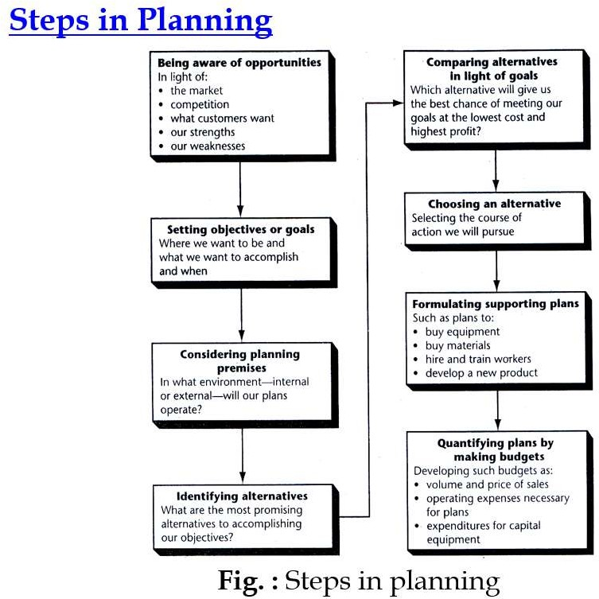

## Being Aware of Opportunities

1. **Establishing Objectives**

## Developing Premises

**Premises :** Assumptions about the environment in which the plan is to be carried

out.

**Principle of planning premises :** The more thoroughly individuals charged with

planning understand and agree to utilize consistent planning premises, the more coordinated enterprise planning will be.

## Determining Alternative Courses

1. **Evaluating Alternative Courses**

## Selecting a Course

1. **Formulating Derivative Plans, and**
2. **Quantifying Plans by Budgeting**

# Steps in Decision Making

**Principles of Organisation**

1. **Application Blank**

# Steps in Selection Process

Filling the application blank is the first step in selection process

Applicant give relevant data: Qualification, specialization, experience, firms in which he worked/working currently, other basic information viz… address, dependants, interests, hobby etc.,,

## Preliminary Interview

The purpose of this interview is to scrutinize the applicants, i.e. elimination of unqualified applications.

It is most important means of evaluating the candidate. It used to obtain the basic information about candidate.

## Selection Tests

Different types of selection tests may be administrated, depending on the job and the company. Generally, tests are used to determine the applicant’s ability, aptitude, and personality.

* 1. *Aptitude test*: capacity to learn the skill required for a job. [to assess training needs]
  2. *Interest test*: type of work in which candidate has interest. [sale, field work, manufacturing]
  3. *Personality test*: characteristics of a candidate such as self-confidence, initiative, judgment, dominance, integrity, originality etc.,, very important for supervisory and top positions.

## Employment Interview

The next step in the selection process is employment interview, an interview is conducted at the beginning, and at the selection process of the employment interview can be one- to-one interview or panel interview.

## Reference and Background Checks

Many employers request names, address, telephone numbers or references for the purpose to verify information and gaining additional background information of an applicant.

## Selection Decision

Selection decision is the most critical of all steps in selection process. The final decision has to be made from the pool of individuals who pass the tests, interviews and references checks.

## Physical Examinations/Medical Examinations

After selection decision and before the job offer is made, the candidate is required to undergo a physical fitness test. A job offer is often; contingent upon the candidate being declared fit after the physical examinations.

## Job Offer

The next step in selection process is job offer. Job offer is made through a letter of appointment. Such a letter generally contains a date by which the appointee must report on duty.

## Contract of Employment

Basic information is written in Contract of employment that varies according to the levels of job. After the offer and acceptance of the job certain document is the attestation form.

## Evaluation of Selection program: [optional step]

The broad test of effectiveness of the selection process is a systematic evaluation. A periodic audit is conducted in the HR department that outlines and highlights the areas which need to be evaluated in the selection process

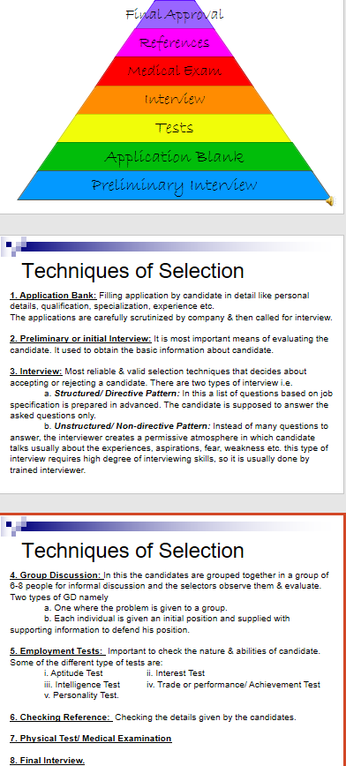

# Motivation Theories

**STEPS IN CONTROLLING**

## Control is reciprocally related to planning :

* Draws attention to situations where new planning is needed.
* Provides data upon which plans can be based.

## Various steps in control process which are necessary in its relationship to planning :

1. **Establishment of control standards.**

Plans - goals, objectives, targets to be achieved. Actual results are measured against them.

Precision :

Great precision – Standards are set in quantities.

E.g. Physical – Volume of products, man hour. Monetary – Costs, revenues, investment.

Less precision – Standards are in qualitative terms.

E.g. Human relations.

It is also important to decide the level of achievement which will be regarded as good or satisfactory.

Desired level of performance - reasonable , feasible, some amount of flexibility , stated in terms of range (maximum and minimum).

## Measurement of performance.

Involves measuring the performance in the work in terms of control standards. Methods of measuring performance :

Quantitative – Physical and monetary terms, easily and precisely measurable.

E.g. Production units, sales, volume, profits etc. Qualitative – Intangible, cannot be measured precisely.

E.g. Human relations etc.

Techniques – Psychological tests, opinion surveys.

Measurement must be (i) clear, simple and rational, (ii) relevant, (iii) direct attention and efforts, (iv) reliable, self-announcing, and understandable without complicated interpretation or philosophical discussions.

## Comparison between performance and standards and the communication.

Steps: Finding out the **extent of deviations**.

Identifying the **causes of such deviations**.

**Accurate standards** and **accurate measurement of actual performance** are very important for clear revelation of variations.

Required standards achieved: No further managerial action is necessary.

Control process is complete.

Required standards not achieved:

Extent of variation may differ from case to case, depends upon the type of activity.

Strict compliance with standards or permissible limit of variation.

E.g. Engineering products – a very minute variation may be significant.

When the deviation between standard and actual performance is beyond the prescribed limit, an analysis is made of the causes of such deviation.

**Controllable factors** – Person concerned will take necessary corrective action.

**Uncontrollable factors** – Person concerned cannot be held responsible.

**Communication of data** to the person who can take corrective action.

## Correction of deviation from the standards.

Organization is not a self – regulating system.

Actions should be taken to maintain the desired degree of control in the system or operation.

Control actions :

* + Review of plans and goals and change therein on the basis of such review.
  + Change in the assignment of tasks.
  + Change in existing techniques of direction.
  + Change in the organization structure.
  + Provision for new facilities.

# Needs of an Employee